
Date: 24-07-2025
Subject : CBSE Cluster VI Athletic Championship winner - 2025
Dear Parents,
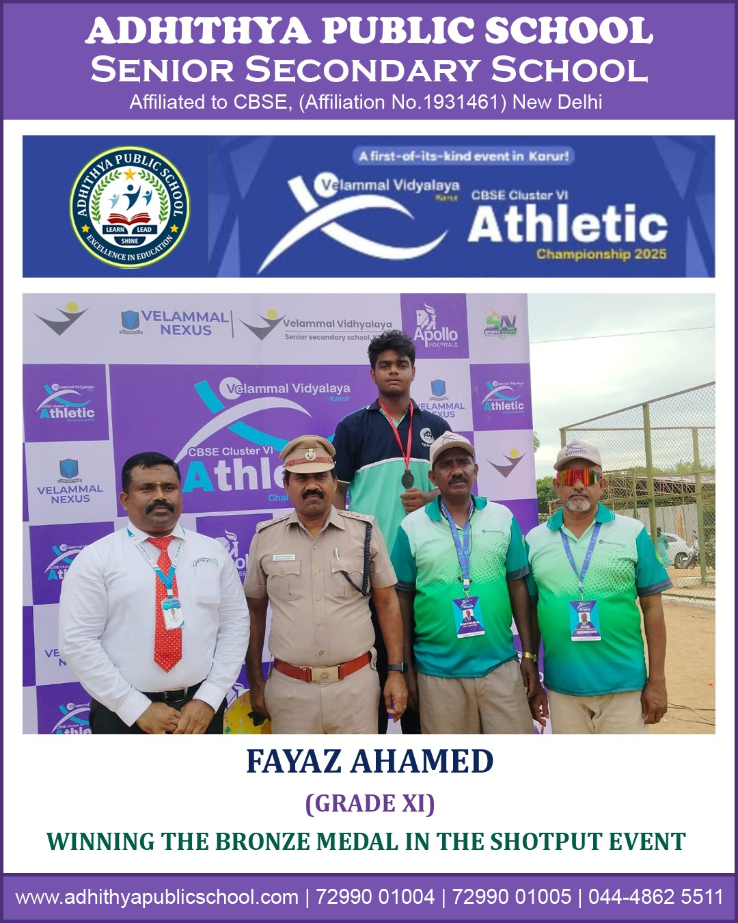We are thrilled to inform you that our school actively participated in the prestigious CBSE Cluster VI Athletic Championship 2025, hosted at Velammal Vidyalaya, Karur. This five-day mega event featured 70 athletic events, over 1,000 schools, and witnessed more than 15,000 student participants from across Pondicherry, Andaman and Tamil Nadu.
Amidst fierce competition and tremendous talent, our student A.Fayaz Ahamed of Grade XI made us immensely proud by winning the Bronze Medal in the Shotput event. He was honored on stage and received a medal and certificate in recognition of his remarkable performance.
- S. Vetrimaran
- P. Dharanya
- A. Sulaiman
- N. Eric Natraj
- V. Monish
- N. Yaazhini
- A. Mohammed Afrith
- V. Lakshaya
- S. Abhinaya Sri
- S. Harrish Mohammed
- P. Holika
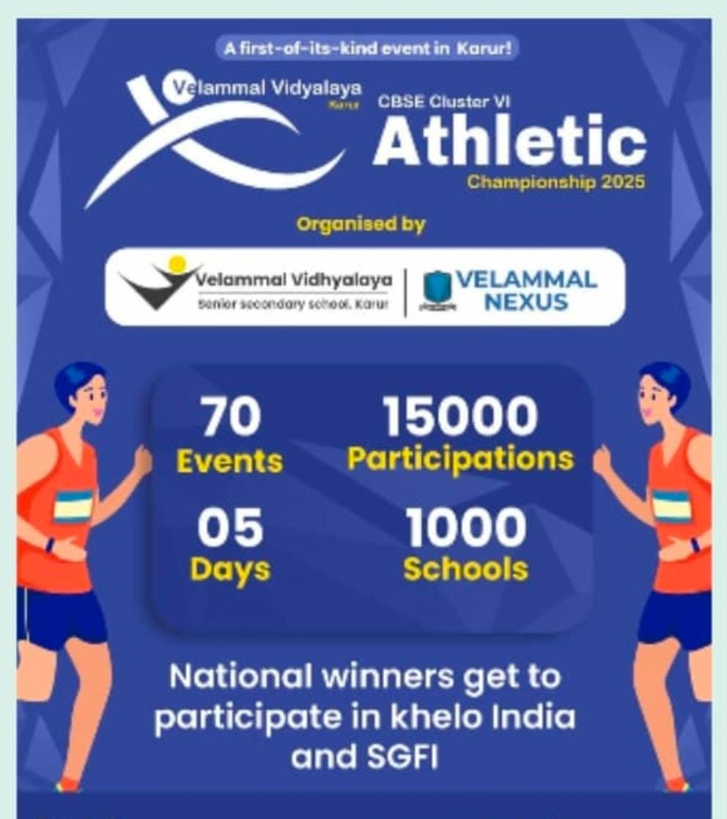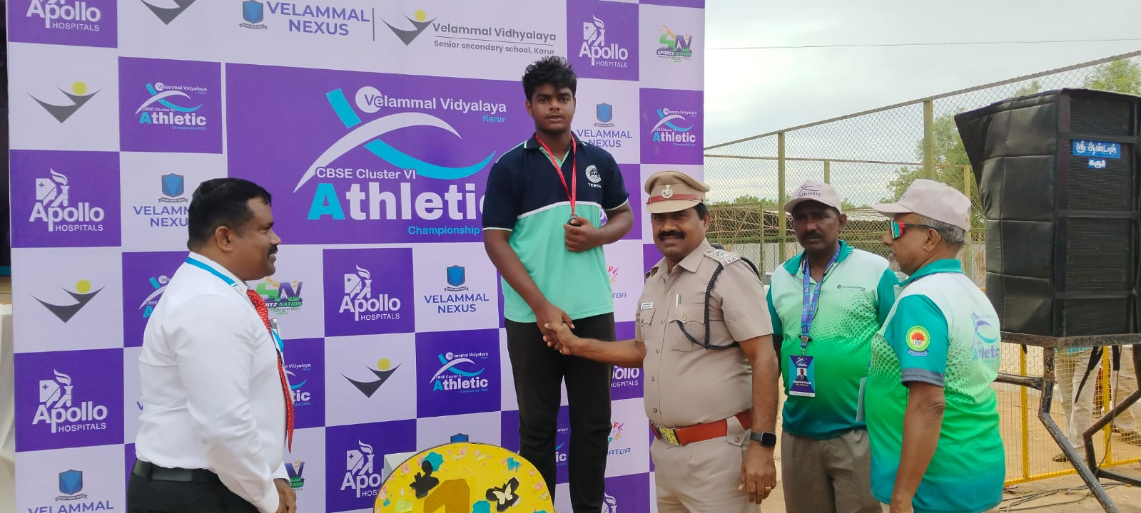Other participating students also received participation certificates in recognition of their efforts.

This victory is a testament to his hard work, discipline, and the unwavering support of our physical education team. We congratulate A. Fayaz Ahamed and all our student-athletes who represented the school with great spirit and dedication.
Thank you, for your constant encouragement and support in nurturing our students to aim higher and excel in all spheres.
Warm regards,
Principal.

